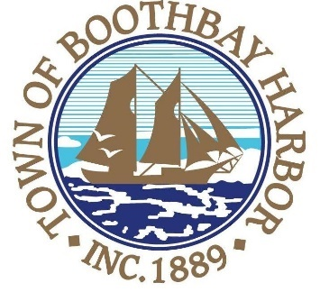

TOWN OF BOOTHBAY HARBOR
SELECTMEN’S MEETING AGENDA
Monday, January 13, 2020
Boothbay Harbor Town Office, 11 Howard Street

7:00 p.m.
CALL TO ORDER:

- Pledge of Allegiance
- Introduction of Town Manager & Board of Selectmen
- Town Manager Announcement(s)
- Town Department Reports
- Selectmen Reports
- Financials
- Minutes Approval – December 23, 2019
- Licenses
  - Liquor license (s), New, Vinous, Harbor Theater, 185 Townsend Avenue, Boothbay Harbor
- New Business
  - Boothbay Region Land Trust-monetary donation acceptance
- Old Business
  - Baker Design Consultants, Footbridge project presentation
- Public Forum
- Warrants
- Executive Session
- Motion to Adjourn

In addition to written minutes, Selectmen’s meetings are recorded on video by BRCTV
and audio recordings are available to be listened to at the Boothbay Harbor Town Office

