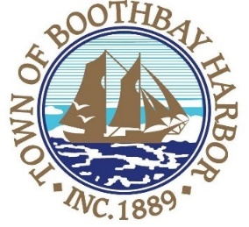
TOWN OF BOOTHBAY HARBOR
SELECTMEN’S MEETING AGENDA
Monday, January 25, 2021
VIRTUAL MEETING (VIA ZOOM): See instructions to connect below
Boothbay Harbor Town Office, 11 Howard Street
7:00 p.m.
CALL TO ORDER:
- Introduction of Town Manager & Board of Selectmen
- Town Manager Announcement(s)
- Town Department Reports
- Selectmen Reports
- Financials
- Minutes Approval – January 11, 2020
- Licenses
- New Business
  - RFP-Broadband
  - Personnel Policy adoption
- Old Business
  - Atlantic Avenue sidewalk discussion
  - Covid-19 discussion
- Public Forum
- Warrants
- Executive Session
- Motion to Adjourn
Connecting by computer: You may be required to download the Zoom app in order to connect. This is free, and easy to use. Make sure to log in a few minutes early to ensure you can connect.
Using your computer, go to: https://us02web.zoom.us/j/85984494986 Meeting ID: 859 8449 4986
Connecting by phone:
- Public participants can use their mobile phones using the number below: (929) 205-6099, meeting id (85984494986#). If you are using a regular phone, please dial the phone number (929) 205-6009, and you will be asked to enter the Meeting ID number (85984494986) followed by the # sign.
PLEASE REMEMBER TO ENABLE AUDIO TO LISTEN TO THE MEETING

