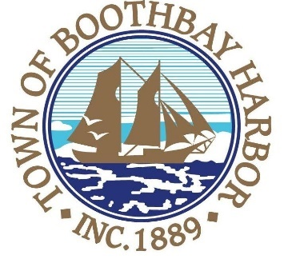

TOWN OF BOOTHBAY HARBOR
SELECTMEN’S MEETING AGENDA
Tuesday, October 15, 2019
Boothbay Harbor Town Office, 11 Howard Street

7:00 p.m.
CALL TO ORDER:

- Pledge of Allegiance
- Introduction of Acting Town Manager & Board of Selectmen
- Acting Town Manager Announcement(s)
- Town Department Reports
- Selectmen Reports
- Financials
- Minutes Approval – September 23, 2019
- Licenses
- New Business
  - Cody Mitchell Presentation-BRTV
  - Approve and sign warrant for Special Town Meeting (November 5, 2019)
- Old Business
  - Review and approve updated JEDC Economic Development Agreement
- Public Forum
- Warrants
- Executive Session
- Motion to Adjourn

In addition to written minutes, Selectmen’s meetings are recorded on video by BRCTV
and audio recordings are available to be listened to at the Boothbay Harbor Town Office

