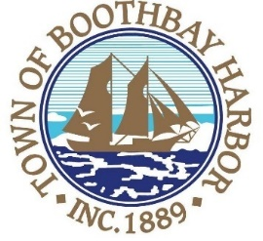
TOWN OF BOOTHBAY HARBOR
SELECTMEN’S MEETING AGENDA
Tuesday, October 26, 2020
Boothbay Harbor Town Office, 11 Howard Street
7:00 p.m.
Due to limited space in the meeting room to meet COVI9-19 guidelines for safety, we are also providing a Zoom meeting id and number to call for audio purposes:
https://us02web.zoom.us/j/87234137063
MEETING ID: 838 5477 3024 TELEPHONE NUMBER: 1-929-205-6099

CALL TO ORDER:
- Pledge of Allegiance
- Introduction of Town Manager & Board of Selectmen
- Town Manager Announcement(s)
- Town Department Reports
  - Town Clerk, Michelle Farnham (Election)
- Selectmen Reports
- Financials
- Minutes Approval – October 13, 2020
- Licenses
  - Liquor License, Malt, Spirituous & Vinous, Brady’s, 25 Union Street, renewal.
  - Outdoor Event License, Harbor Theater Movie Night, Meadow Mall Parking Lot, 185 Townsend Avenue, new.
- New Business
- Old Business
  - Covid-19 discussion
- Public Forum
- Warrants
- Executive Session
- Motion to Adjourn

