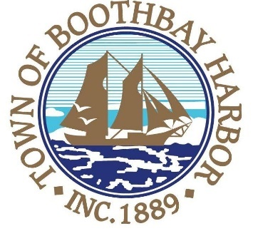

TOWN OF BOOTHBAY HARBOR
SELECTMEN’S MEETING AGENDA
Monday, October 28, 2019
Boothbay Harbor Town Office, 11 Howard Street

7:00 p.m.
CALL TO ORDER:

- Pledge of Allegiance
- Introduction of Acting Town Manager & Board of Selectmen
- Acting Town Manager Announcement(s)
- Town Department Reports
  - Police Chief Robert Hasch
- Selectmen Reports
- Financials
- Minutes Approval – October 15, 2019
- Licenses
  - Mama D’s Café, Renewal, 50 Union Street, Malt & Vinous
- New Business
  - Public Hearing-Adopt the Maine Municipal Association’s new (October 1, 2019-September 30, 2020) “General Assistance Ordinance Appendix” (A-D)
  - P.O. for BRTV Live Video Conference System
- Old Business
a. JEDC-discussion/representatives
- Public Forum
- Warrants
- Executive Session
- Motion to Adjourn

In addition to written minutes, Selectmen’s meetings are recorded on video by BRCTV
and audio recordings are available to be listened to at the Boothbay Harbor Town Office

