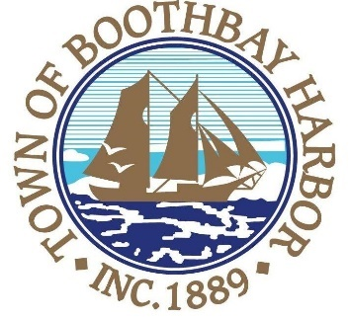

TOWN OF BOOTHBAY HARBOR
SELECTMEN’S MEETING AGENDA
Tuesday, November 12, 2019
Boothbay Harbor Town Office, 11 Howard Street

7:00 p.m.
CALL TO ORDER:

- Pledge of Allegiance
- Introduction of Acting Town Manager & Board of Selectmen
- Acting Town Manager Announcement(s)
- Town Department Reports
  - Public Works Foreman, Nick Upham
- Selectmen Reports
- Financials
- Minutes Approval – October 28, 2019
- Licenses
  - Liquor license (s), Malt & Vinous, Red Cup Coffeehouse, 29 Commercial Street, renewal
  - Liquor license (s), Malt, Spirituous & Vinous, The Thistle Inn, 55 Oak Street, renewal
- New Business
  - Wharves and Weirs Hearing, PGC8 LLC, represented by Melissa Neel and Chuck Fuller, Map #16, Lot #28, 49 Atlantic Ave., on site hearing was held on November 12, 2019 at 4:00 p.m.
- Old Business
  - Election results
- Public Forum
- Warrants
- Executive Session
- Motion to Adjourn

In addition to written minutes, Selectmen’s meetings are recorded on video by BRCTV
and audio recordings are available to be listened to at the Boothbay Harbor Town Office

