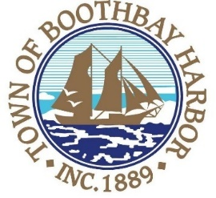
TOWN OF BOOTHBAY HARBOR
LICENSING BOARD MEETING AGENDA
Monday, November 9, 2020
Boothbay Harbor Town Office, 11 Howard Street
7:00 p.m.
Due to limited space in the meeting room to meet COVI9-19 guidelines for safety, we are also providing a Zoom meeting id and number to call for audio purposes:
https://us02web.zoom.us/j/82202862945
MEETING ID: 822 0286 2945 TELEPHONE NUMBER: 1-929-205-6099

CALL TO ORDER:
- Introduction of Licensing Board
- Chair/Vice-Chair Vote
- Licenses
  - Victualer License, House of Pizza, 185-E Townsend Avenue, Class H, new.
- Motion to Adjourn
BOARD OF SELECTMEN MEETING AGENDA
CALL TO ORDER:
- Pledge of Allegiance
- Introduction of Town Manager & Board of Selectmen
- Town Manager Announcement(s)
- Town Department Reports
- Selectmen Reports
- Financials
- Minutes Approval – October 26, 2020
- Licenses
- New Business
- Old Business
  - Boothbay Lights update
  - Atlantic Avenue Sidewalk discussion
  - Footbridge Renovation Project
  - Covid-19 discussion
- Public Forum
- Warrants
- Executive Session
  - MRSA Title 1, Chapter 13, § 405 6 (C), Discussion/Negotiations about publicly held property
- Motion to Adjourn

