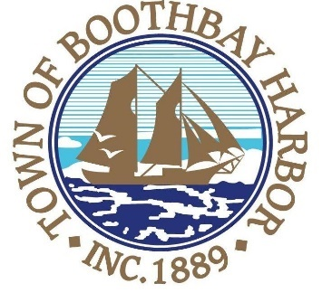
TOWN OF BOOTHBAY HARBOR
SELECTMEN’S MEETING AGENDA
Monday, December 14, 2020
VIRTUAL MEETING (VIA ZOOM): See instructions to connect below
Boothbay Harbor Town Office, 11 Howard Street

7:00 p.m.
CALL TO ORDER:

- Introduction of Town Manager & Board of Selectmen
- Town Manager Announcement(s)
- Town Department Reports
- Selectmen Reports
- Financials
- Minutes Approval – November 23, 2020
- Licenses
  - Liquor License, Malt, Spirituous & Vinous, China by the Sea, 96 Townsend Avenue, renewal
- New Business
  - Fred Brewer, CPA (audit presentation)
- Old Business
- Public Forum
- Warrants
- Executive Session
- Motion to Adjourn
Connecting by computer: You may be required to download the Zoom app in order to connect. This is free, and easy to use. Make sure to log in a few minutes early to ensure you can connect.
Using your computer, go to:
https://us02web.zoom.us/j/82922117343 Meeting ID: 829 2211 7343

Connecting by phone:
- Public participants can use their mobile phones using the number below: (929) 205-6099, meeting id (82922117343#). If you are using a regular phone, please dial the phone number (929) 205-6009, and you will be asked to enter the Meeting ID number (82922117343) followed by the # sign.
PLEASE REMEMBER TO ENABLE AUDIO TO LISTEN TO THE MEETING

