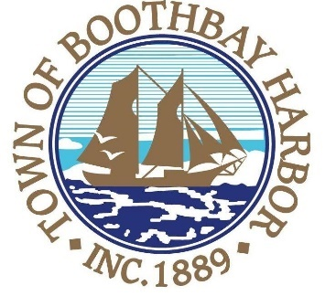

TOWN OF BOOTHBAY HARBOR
SELECTMEN’S MEETING AGENDA
Monday, December 9, 2019
Boothbay Harbor Town Office, 11 Howard Street

7:00 p.m.
CALL TO ORDER:

- Pledge of Allegiance
- Introduction of Town Manager & Board of Selectmen
- Town Manager Announcement(s)
- Town Department Reports
- Selectmen Reports
- Financials
- Minutes Approval – November 25, 2019
- Licenses
- New Business
  - Wharves and Weirs Hearing, Janet Hamblen, represented by Lauren Stockwell, Map #25 Lot #12, 347 Lakeside Drive, on site hearing was held on December 9, 2019 at 3:00 p.m.
  - Wharves and Weirs Hearing, PGC8 LLC, represented by Melissa Neel and Chuck Fuller, Map #16, Lot #28, 49 Atlantic Ave., on site hearing was held on November 12, 2019 at 4:00 p.m.
  - Boothbay Region Ambulance Service, Robbie Ham
- Old Business
- Public Forum
- Warrants
- Executive Session
- Motion to Adjourn

In addition to written minutes, Selectmen’s meetings are recorded on video by BRCTV
and audio recordings are available to be listened to at the Boothbay Harbor Town Office

