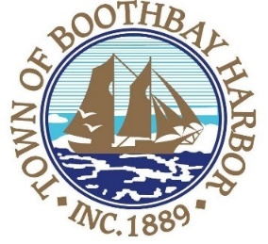
TOWN OF BOOTHBAY HARBOR
SELECTMEN’S MEETING AGENDA
Monday, March 8, 2021
VIRTUAL MEETING (VIA ZOOM): See instructions to connect below
Boothbay Harbor Town Office, 11 Howard Street
7:00 p.m.
CALL TO ORDER:
- Introduction of Town Manager & Board of Selectmen
- Town Manager Announcement(s)
- Town Department Reports
- Selectmen Reports
- Financials
- Minutes Approval – February 22, 2021
- Licenses
  - Liquor License, Malt, Spirituous & Vinous, Mine Oyster Inc., 16 Wharf Street, renewal.
  - Liquor License, Malt, Spirituous & Vinous, Topside Inn, 60 McKown Street, renewal.
  - Special Amusement License, Shannon’s Unshelled, DBA: The Tinnery, 23 Granary Way, new.
  - Special Amusement License, Mine Oyster Inc., 16 Wharf Street, renewal.
- New Business
  - Annual Town Report printing bid approval
- Old Business
  - Review of proposed draft ordinances
  - Rt. 27 Sidewalk construction bid update
  - Covid-19 discussion
- Public Forum
- Warrants
- Executive Session
- Motion to Adjourn
Connecting by computer: You may be required to download the Zoom app in order to connect. This is free, and easy to use. Make sure to log in a few minutes early to ensure you can connect.
Using your computer, go to: https://us02web.zoom.us/j/85161333263 Meeting ID: 85161333263
Connecting by phone:
- Public participants can use their mobile phones using the number below: (929) 205-6099, meeting id (85161333263#). If you are using a regular phone, please dial the phone number (929) 205-6009, and you will be asked to enter the Meeting ID number (85161333263) followed by the # sign.
PLEASE REMEMBER TO ENABLE AUDIO TO LISTEN TO THE MEETING

