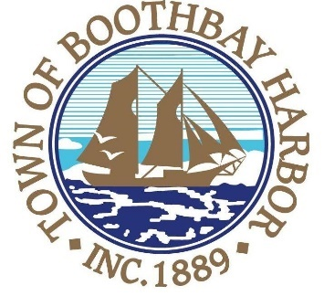
TOWN OF BOOTHBAY HARBOR
SELECTMEN’S MEETING AGENDA
Monday, June 8, 2020
Boothbay Harbor Town Office, 11 Howard Street

7:00 p.m.
CALL TO ORDER:

- Introduction of Town Manager & Board of Selectmen
- Town Manager Announcement(s)
- Town Department Reports
- Selectmen Reports
- Financials
- Minutes Approval – May 26, 2020
- Licenses
  - Liquor License, Malt, Spirituous & Vinous, Fisherman’s Wharf Inn, 22 Commercial Street, renewal
  - Special Amusement License, Boothbay Harbor Yacht Club, 156 Western Avenue, renewal
  - Victualer license, Boothbay Harbor Yacht Club, 156 Western Avenue, Class H, new
  - Victualer license, Thistle Inn, 55 Oak Street, Class H, new
  - Victualer license, Wannawaf Inc., 31 Granary Way, Class D, new
  - Victualer license, Atlantic Ark Inn, 62 Atlantic Avenue, Class F, new
  - Victualer license, Eventide Specialties, 5 Boothbay House Hill, Class B, new
- New Business
  - Adopt Fee Schedule for 2020/2021
  - P.O. Baker Design Consultants
  - P.O. Town of Boothbay (Cost Share-Casco Bay Advisors/Broadband)
  - Approve Carry-Forward amounts for 2020/2021
  - Annual Municipal Appointments/Boards and Committees
- Old Business
- Public Forum
- Warrants
- Executive Session
- Motion to Adjourn

