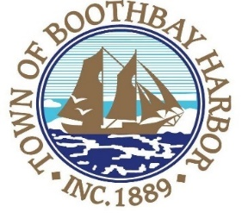
TOWN OF BOOTHBAY HARBOR
SELECTMEN’S MEETING AGENDA
Monday, August 12, 2019
Boothbay Harbor Town Office, 11 Howard Street

6:00 p.m.
Executive Session Pursuant to Title 1, Chapter 13, §405, (6) E. Legal Consultation.

7:00 p.m.
CALL TO ORDER:

- Pledge of Allegiance
- Introduction of Acting Town Manager & Board of Selectmen
- Acting Town Manager Announcement(s)
- Town Department Reports
- Selectmen Reports
  - Report on August 5, 2019 workshop with Eaton Peabody Consulting Group
- Financials
- Minutes Approval – July 22, 2019
- Licenses
  - Victualer license, Farm 23, 102 Ocean Point Road, Class F.
- New Business
  - Wharves and Weirs Hearing, David William Iverson Revocable Trust, represented by Lauren Stockwell, on site hearing was held on August 12, 2019 at 4:30 p.m.
  - Application for Broadband Committee
  - Landscape RFP for BB/PB Courts
  - Presentation by Chris Swanson and Geoff Smith re: The Museum in the Streets
  - Administrative ordinance discussion pertaining to Chapter 2, §2-4 (D), Town Finances
- Old Business
- Public Forum
- Warrants
- Executive Session Title 1, Chapter 13, §405, (6) A. Personnel
- Motion to Adjourn

In addition to written minutes, Selectmen’s meetings are recorded on video by BRCTV
and audio recordings are available to be listened to at the Boothbay Harbor Town Office

