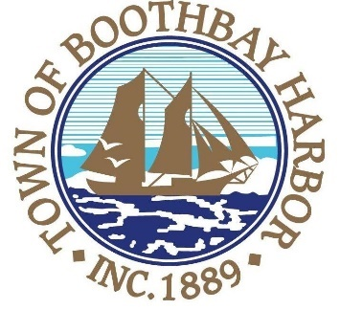

TOWN OF BOOTHBAY HARBOR
SELECTMEN’S MEETING AGENDA
Monday, September 9, 2019
Boothbay Harbor Town Office, 11 Howard Street

7:00 p.m.
CALL TO ORDER:

- Pledge of Allegiance
- Introduction of Acting Town Manager & Board of Selectmen
- Acting Town Manager Announcement(s)
- Town Department Reports
- Selectmen Reports
- Financials
- Minutes Approval – August 26, 2019
- Licenses
  - Victualer(s), Slice O’Country, 23 Highland Park Road, Class A, new
- New Business
  - William H. Brewer, CPA (Fred Brewer)-Annual Audit Presentation FY 2019
- Old Business
  - The Museum in the Streets
- Public Forum
- Warrants
- Executive Session
- Motion to Adjourn

In addition to written minutes, Selectmen’s meetings are recorded on video by BRCTV
and audio recordings are available to be listened to at the Boothbay Harbor Town Office

