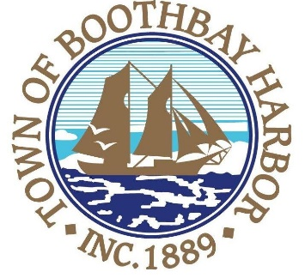

TOWN OF BOOTHBAY HARBOR
SELECTMEN’S MEETING AGENDA
Monday, July 22, 2019
Boothbay Harbor Town Office, 11 Howard Street
6:00 p.m.

Executive Session Pursuant to Title 1, Chapter 13, §405, (6) A. Personnel

7:00 p.m.
CALL TO ORDER:

- Pledge of Allegiance
- Introduction of Town Manager & Board of Selectmen
- Town Manager Announcement(s)
- Town Department Reports
- Selectmen Reports
- Financials
- Minutes Approval – July 8, 2019
- Licenses
  - Liquor License Renewal, Waves Restaurant, Inc.
- New Business
  - Boston Post Cane nomination
  - P.O. Public Works-Sickle Bar Mower
  - Mobile Food Vendor discussion
- Old Business
- Public Forum
- Warrants
- Executive Session
- Motion to Adjourn

In addition to written minutes, Selectmen’s meetings are recorded on video by BRCTV
and audio recordings are available to be listened to at the Boothbay Harbor Town Office

