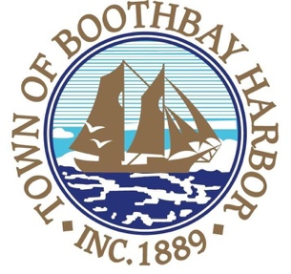

Finance Officer

Town of Boothbay Harbor

The Town of Boothbay Harbor is seeking a qualified individual for the position of Finance Officer. This position operates with broad guidelines from the Town Manager with considerable independence of action in accordance with applicable laws and generally accepted accounting practices and established policies and procedures. This position requires strong organizational skills and excellent attention to detail with a high degree of accuracy since the Finance Officer is responsible for maintaining all financial records, disbursement of all monies, including maintaining and reconciling bank ledgers for the town and for assisting with employee-related activities and human resource. The Finance Officer performs weekly payroll functions and related benefit administration duties. These duties include, but are not limited to; preparing and processing accounts payable, administering general assistance, overseeing accounts receivable function of the assistant tax collectors, managing grant and investment transactions, scheduling and preparing for audits, forecasting salary and benefit calculations, assisting the Town Manager with developing and preparing the town budget, reporting budget standings to department heads, Select Board and Town Manager.
A two-year college degree in accounting or business administration, a four-year college or university degree in accounting administration or related field preferred. Three (3) years of experience working in an accounts payable/receivable position and one (1) year experience processing payroll and benefits preferred. Prior municipal experience is desired. Candidates must be bondable and pass a financial/criminal background check. Salary will be determined based on experience and qualifications. Interested applicants should submit cover letter, resume, and five references by 4:00 p.m. on Tuesday, November 26, 2019, to jlatter@boothbayharbor.org or in person or by mail to: Julia E. Latter, Town Manager, 11 Howard St., Boothbay Harbor, Maine 04538.
The Town of Boothbay Harbor is an Equal Opportunity Employer. All qualified applicants will be considered for employment without regard to race/ethnicity, gender, qualified protected veteran or disability status.

