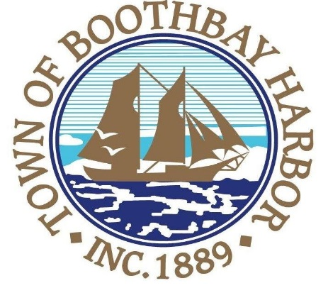
Town of Boothbay Harbor Planning Board
AGENDA
Wednesday, February 13, 2019
7:00 PM
Boothbay Harbor Town Hall
11 Howard St.
- Call to Order

- Roll Call of Members

- Old Business

- Approval of January 9, 2019 Minutes

- New Business
- PGC8 LLC, represented by Melissa Neel, 61 Atlantic Ave. Tax Map 16, Lot 25, applicant proposes to demolish an existing multi-family dwelling and construct a single-family dwelling, requiring Planning Board approval under Chapter 170, Article III, Section 170-27 ( E) of the Code of the Town of Boothbay Harbor.
- Katama Acquisitions LLC, represented by Steve Roberge, 4 and 5 Nahanada Road, Tax Map 11, Lots 9 and 8B, Applicant proposes to construct a new storage building, a swimming pool, and expand existing parking lots, requiring Planning Board approval under Chapter 170, Article V, Section 170-61 of the Code of the Town of Boothbay Harbor.

- Other Business

- Jane Carpenter, to discuss the possibility of creating an ordinance to address blasting.

- Adjourn

