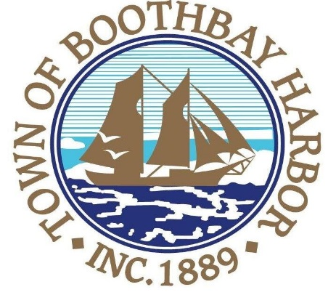
Town of Boothbay Harbor Planning Board
AGENDA
Wednesday, October 10, 2018
7:00 PM
Boothbay Harbor Town Hall
11 Howard St.
- Call to Order

- Roll Call of Members

- Old Business

- Approval of September 12, 2018 Minutes

- New Business

- Other Business
- Zander Shaw, pre-application discussion regarding possible work at Linekin Bay Resort

- Continue discussion of possible amendments to the ordinance

- Adjourn

