LOCAL RESOURCES FOR THE BOOTHBAY REGION 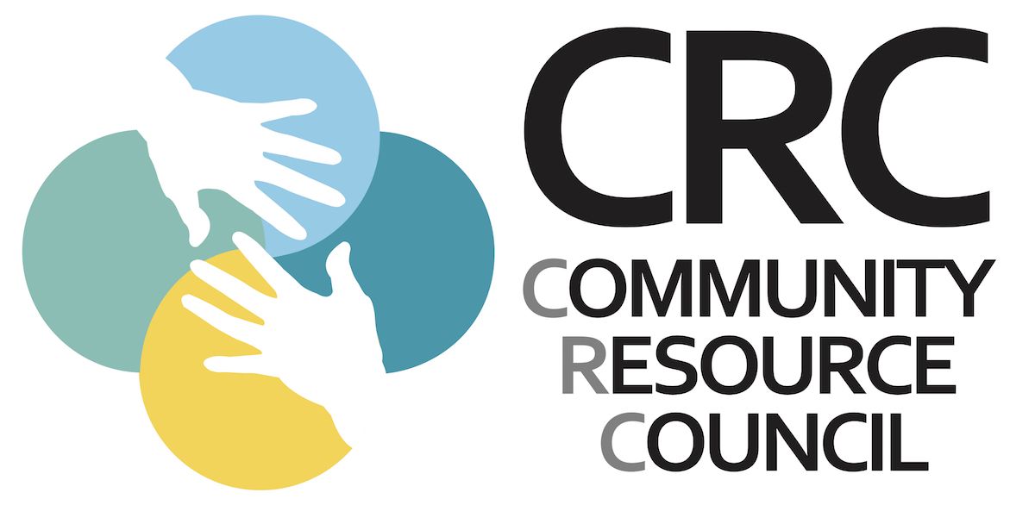

FOOD RESOURCES

AOS 98: School Lunch
Monday-Friday 11:30-12:30 with curbside pickup at Main Entrance:
- Boothbay Region Elementary School
- Southport Central School
- Edgecomb Eddy School

Boothbay Region YMCA Student Curbside Grab & Go Meals
Stephanie Tucker 633-2855
- Monday-Friday 5:30 am to 6 pm
- Saturday 7:00 am to 5 pm

Boothbay Region Food Pantry
Fleet Davies 350-2962
- Fridays 11:30-1:30
- Delivery available, call ahead
- Updates provided on Facebook page

Boothbay Rides Grocery Delivery Assistance
Volunteer driver delivery. Requires 48 hour notice. Breanna Davis 633-4357

Food for Thought (healthy snack options for the weekend): Hannah Corkum 350-1743
- In-home delivery every Fridays

Hannaford Supermarket (7am – 9 pm):
Senior Shopping Time: Tue-Thurs, 7- 8 am
Manager: Nikki Emerson 633-6465

Meals on Wheels (elderly in-home meal delivery): Pat Wheeler 633-4370 or Mary Lou Koskela 633-5161

Wiscasset Food Pantry: 882-9088

MUNICIPAL RESOURCES

Boothbay Town Office: 633-2051
Boothbay Harbor Town Office: 633-3671
Boothbay Harbor Police: 633-5616

OTHER LOCAL RESOURCES

Community Resource Council
-Hannah Corkum 350-1743 (client services)
-Breanna Davis 633-4357 (volunteer coordinator; meal/grocery delivery)
-Holly Stover 350-7477

Boothbay Harbor Memorial Library
Unemployment Filing Assistance Only
Joanna Breen 633-3112

Health Care Facilities
Family Care Center-BBH: 633-7820
Lincoln Health-Damariscotta: 563-1234
Mid Coast Hospital: 373-6000
Boothbay Region Health Center: 633-1075
(M-F 8:00-4:30; Sat 10-4)
St. Andrews Urgent Care: 633-2121
(temporarily closed during COVID surge)
Lincoln County Dental 386-6600 (Medicaid
& sliding fee) 93 Churchill Street, Wiscasset

Pharmacies
Nathan’s Pharmacy: 315-2280
- Curbside pick-up and home delivery
Walgreens: 633-7023
- Curbside (all predicts; order online); home delivery of medications only

Mental Health Services
Addiction Outreach- BRCRC: 350-7477
Addiction Resource Center: 373-6950
Alanon-Statewide: 800-498-1844
Alcoholics Anonymous- 800-737-6237
Alliance on Mental Illness (NAMI): 800-464-5767
BB Region Nursing & Outreach: 633-5533
Child Protective Services- DHHS: 800-452-1999
Domestic Violence Hotline: 866-834-4357
Healthy Lincoln County: 563-1330
Low Cost Drug Program: 855-797-4357
Maine Behavioral Health: 884-292-0111
Mid Coast Hospital Outpatient Behavioral Health: 373-6980
New Hope for Women: 800-522-3304
Sexual Assault Support Services: 800-871-7741
Sweetser Behavioral Health: 800-434-3000 VA Medical Center/Togus: 877-421-8263

