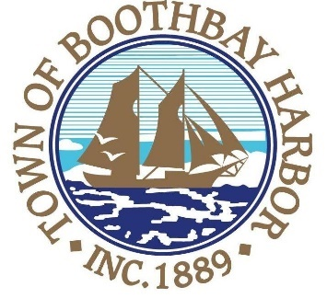

TOWN OF BOOTHBAY HARBOR
SELECTMEN’S MEETING AGENDA
Monday, September 23, 2019
Boothbay Harbor Town Office, 11 Howard Street

7:00 p.m.
CALL TO ORDER:

- Pledge of Allegiance
- Introduction of Acting Town Manager & Board of Selectmen
- Acting Town Manager Announcement(s)
- Town Department Reports
  - Police Chief Robert Hasch
- Selectmen Reports
- Financials
- Minutes Approval – September 8, 2019
- Licenses
  - Victualer license (s), Shannon’s Unshelled, 23 Granary Way, Class H, new
  - Liquor license (s), Malt, Spirituous & Vinous, China by the Sea, 96 Townsend Avenue, renewal
- New Business
  - Atlantic Avenue Sidewalk Feasibility Study presentation/Barney Baker Design Consultants
  - New Hope for Women, Mary Hanley
- Old Business
  - Follow-up with code enforcement officer
- Public Forum
- Warrants
- Executive Session
- Motion to Adjourn

In addition to written minutes, Selectmen’s meetings are recorded on video by BRCTV
and audio recordings are available to be listened to at the Boothbay Harbor Town Office

