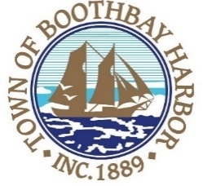
TOWN OF BOOTHBAY HARBOR
PUBLIC NOTICE

After serious consideration, we will be making an adjustment in municipal operations in light of the COVID-19 virus and its potential impact on our community. Effective at 1:00 p.m. on March 19th, 2020, the town office will be closed to all foot traffic until further notice. The staff will be working and actively responding to calls and e-mails during regular business hours. Please call if you need to be seen by appointment for an essential transaction. To access municipal services, please note that a large number of town office services from tax payments, to vehicle re-registrations, recreational and boat re-registrations, to burn permits and more, are available through our website at: www.boothbayharbor.org.

If you are having difficulty accessing these services or are unable to complete your request through our system, please call the town staff at Boothbay Harbor 207-633-3671 or email the offices at:
Town Manager: jlatter@boothbayharbor.org
Town Clerk: mfarnham@boothbayharbor.org
Tax Collection: tfallon@boothbayharbor.org
Code Enforcement: gsmith@boothbayharbor.org
General Assistance: kpearce@boothbayharbor.org
Police Chief: bhasch@boothbayharbor.org
Harbor Master: jlowell@boothbayharbor.org
Public Works/Fire Chief: nupham@boothbayharbor.org
You may also send a message to Boothbay Harbor to be directed through the, "Contact Us", button through Facebook and we will direct your questions or comments to the appropriate department.

We apologize for any inconvenience and look forward to seeing our customers in person once we are able to. We thank you for your understanding and support at this time. Our goal is to ensure the safety of our employees and our residents. Please stay healthy!

