Town Managers Provide Guidance for Accessing Municipal Services

As a result of the COVID-19 global pandemic and Governor Mills civil emergency declaration, the towns of Boothbay Harbor and Boothbay are taking additional precautions to ensure the safety of residents and town staff as we work to continue providing municipal services. We are asking the assistance of the public to adhere to the following guidelines:

- Any person with flu-like symptoms (fever, cough, sore throat, difficulty breathing) should refrain from visiting the town office and contact their health care provider to determine if they need to be tested for COVID-19.
- If you have visited areas where outbreaks of COVID-19 have occurred within the last 14 days, to please refrain from visiting our town office to conduct regular business.
- For the next two weeks, the town office and meeting rooms will not be available for meetings or workshops from outside groups.

To access municipal services, please note that a large number of town office services from tax payments, to vehicle, recreational and boat re-registrations, to burn permits and more, are available through our website at: Boothbay Harbor www.boothbayharbor.org.
Or Boothbay www.boothbay.org
If you are having difficulty accessing these services or are unable to complete your request through our system, please call the town staff at Boothbay Harbor 207-633-3671/or Boothbay at 207-633-2051 or email the offices:

- Town Managers: jlatter@boothbayharbor.org / townmanager@townofboothbay.org
- Town Clerk mfarnham@boothbayharbor.org / Deputy@townofboothbay.org
- Tax Collection tfallon@boothbayharbor.org / Treasurer@townofboothba.org
- CodeEnforcement gsmith@boothbayharbor.org / jlorrain@townofboothbay.org
- Public Works nupham@boothbayharbor.org / PublicWorks@townofboothbay.org
- Police Chief bhasch@boothbayharbor.org

You may also send a message to Boothbay Harbor to be directed through the, "Contact Us", button through Facebook and we will direct your questions or comments to the appropriate department.
To learn more about COVID-19, please call the state-wide 211 to get up to date information.
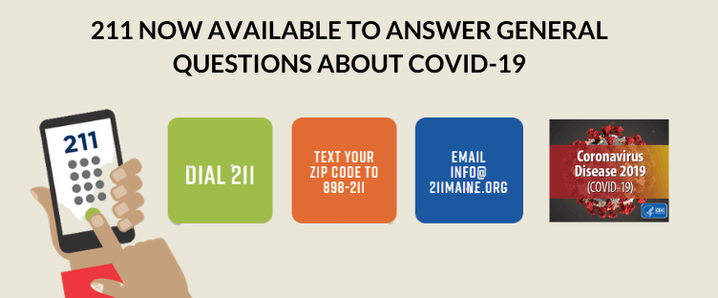

We urge all residents to continue using good hygiene practices, we want to assure the public that we are taking every precaution possible to maintain a safe and sanitary environment for our customers and our employees.

Julia E. Latter, Boothbay Harbor Town Manager
Dan Bryer, Boothbay Town Manager

