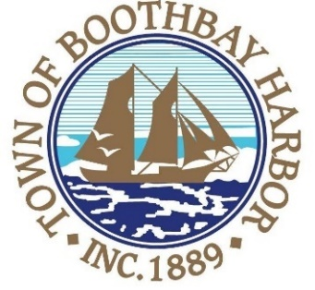

TOWN OF BOOTHBAY HARBOR

PUBLIC HEARING

The Boothbay Harbor Select Board will hold a virtual public hearing on Monday, March 23, 2020 at 6:30 P.M. at the Boothbay Harbor Town Office to review proposed ordinance changes to be presented and voted upon at the Boothbay Harbor Town Meeting held Saturday, May 2nd, 2020, at 9:00 A.M. in the Boothbay Region Elementary School gymnasium.

Governor Mills has banned meetings of more than 10 people to decrease the health risks of COVID-19. On March 17, 2020, the Maine Legislature enacted emergency legislation (PL 2019, c. 617) temporarily authorizing remote participation at municipal board and committee meetings by board members and the public. The public hearing will be live streamed. The Select Board has arranged for the public to safely participate in the March 23 public hearing by remote access. Note that public participants will not be permitted to attend this meeting in person in order to comply with the Governor’s ban.
The Select Board will allow the submission of public comments via video-conference. Individuals submitting comments this way will need to state their name and legal place of residence.
Comments on the proposed ordinances may also be submitted electronically to the Town Manager jlatter@boothbayharbor.org prior to 6 p.m. on March 23.
To participate in the hearing remotely, please register online beforehand.

Connecting by computer: You may be required to download the Zoom app in order to connect. This is free, and easy to use. Make sure to log in a few minutes early to ensure you can connect.
Using your computer, go to https://zoom.us/j/235450567
Meeting ID: 235 450 567

Connecting by phone:
- Pubic participants can use their mobile phones using the number below:
(929) 205-6099, 235450567#
- If you are using a regular phone, please dial the phone number (929) 205-6009, and you will be asked to enter the Meeting ID number (235450567) followed by the # sign.
Questions about the public meeting should be directed to Town Manager, Julia Latter.

