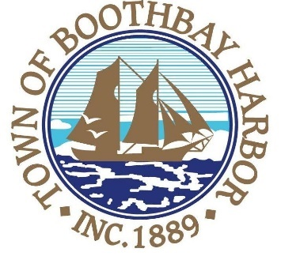

TOWN OF BOOTHBAY HARBOR
SELECTMEN’S MEETING AGENDA
Monday, February 10, 2020
Boothbay Harbor Town Office, 11 Howard Street

7:00 p.m.
CALL TO ORDER:

- Pledge of Allegiance
- Introduction of Town Manager & Board of Selectmen
- Town Manager Announcement(s)
- Town Department Reports
- Selectmen Reports
- Financials
- Minutes Approval – January 27, 2020
- Licenses
  - Liquor License (s), Malt, Vinous & Spirituous, Renewal, Tugboat Inn, 80 Commercial Street
- New Business
  - Port Committee appointment (alternate)
- Old Business
- Public Forum
- Warrants
- Executive Session
- Motion to Adjourn

In addition to written minutes, Selectmen’s meetings are recorded on video by BRCTV
and audio recordings are available to be listened to at the Boothbay Harbor Town Office

