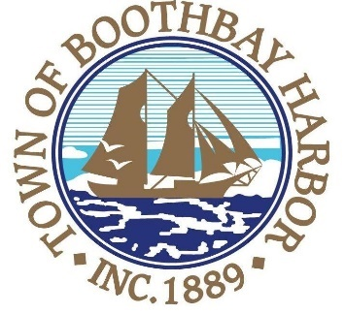

TOWN OF BOOTHBAY HARBOR
SELECTMEN’S MEETING AGENDA
Monday, March 23, 2020
Boothbay Harbor Town Office, 11 Howard Street

6:30 p.m.

A Public Hearing will be held to discuss proposed ordinance changes to be presented and voted upon at the Boothbay Harbor Annual Town Meeting

7:00 p.m.
CALL TO ORDER:

- Pledge of Allegiance
- Introduction of Town Manager & Board of Selectmen
- Town Manager Announcement(s)
- Town Department Reports
  - Public Works Foreman, Nick Upham
- Selectmen Reports
- Financials
- Minutes Approval – March 9, 2020
- Licenses
  - Liquor License, Malt, Spirituous & Vinous, The Opera House, 86 Townsend Avenue, renewal
  - Liquor License, Malt, Spirituous & Vinous, McSeagull’s Restaurant, 14 Wharf Street, renewal
  - Liquor License, Malt, Spirituous & Vinous, Boothbay Harbor Inn, 31 Atlantic Avenue, renewal
  - Liquor License, Malt & Vinous, Boothbay Region House of Pizza, 185E Townsend Avenue, renewal
  - Special Amusement, Brady’s, 25 Union Street, renewal
- New Business
  - Approve and Sign Town Warrant
  - Election clerk appointments
  - Personal property write-offs
- Old Business
- Public Forum
- Warrants
- Executive Session: MRSA Title 1, Chapter 13, § 405 6 (A), Lease discussion
- Motion to Adjourn

In addition to written minutes, Selectmen’s meetings are recorded on video by BRCTV
and audio recordings are available to be listened to at the Boothbay Harbor Town Office

