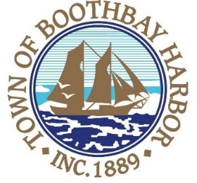

TOWN OF BOOTHBAY HARBOR
SELECTMEN’S MEETING AGENDA
Monday, March 9, 2020
Boothbay Harbor Town Office, 11 Howard Street

6:00 p.m.
- Executive Session under MRSA Title 1, Chapter 13, § 405 6 (D), Labor Contracts
7:00 p.m.
CALL TO ORDER:

- Pledge of Allegiance
- Introduction of Town Manager & Board of Selectmen
- Town Manager Announcement(s)
- Town Department Reports
- Selectmen Reports
- Financials
- Minutes Approval – February 24, 2020
- Licenses
  - Liquor License, Malt, Spirituous & Vinous, Topside Inn, 60 McKown Street, renewal
  - Liquor License, Malt, Spirituous & Vinous, Mine Oyster, 16 Wharf Street, renewal
  - Special Amusement, Mine Oyster Inc., 16 Wharf Street, renewal
- New Business
  - Scott Campbell, EMA discussion/Pandemic Response Plan
- Old Business
  - Review of proposed ordinances
  - Footbridge inspection report
- Public Forum
- Warrants
- Executive Session
  - Executive Session under MRSA Title 1, Chapter 13, § 405 6 (A), Personnel Matters
- Motion to Adjourn

In addition to written minutes, Selectmen’s meetings are recorded on video by BRCTV
and audio recordings are available to be listened to at the Boothbay Harbor Town Office

