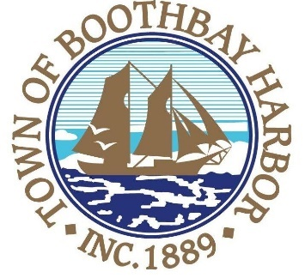
TOWN OF BOOTHBAY HARBOR
SELECTMEN’S MEETING AGENDA
Monday, June 22, 2020
Boothbay Harbor Town Office, 11 Howard Street

7:00 p.m.
Due to limited space in the meeting room to meet COVI9-19 guidelines for safety, we are also providing a Zoom meeting id and number to call for audio purposes:
MEETING ID: 876 0085 1861 TELEPHONE NUMBER: 1-929-205-6099

CALL TO ORDER:

- Pledge of Allegiance
- Introduction of Town Manager & Board of Selectmen
- Town Manager Announcement(s)
- Town Department Reports
- Selectmen Reports
- Financials
- Minutes Approval – June 8, 2020
- Licenses
  - Liquor License, Malt, Spirituous & Vinous, Boothbay Harbor Yacht Club, 156 Western Avenue, renewal
  - Liquor License, Malt, Footbridge Brewery LLC, 25 Granary Way, new (Extension of Premises)
  - Victualer license, Harbor-Tech Solutions, 185 Townsend Avenue, Class E, new
  - Victualer license, Shannon’s Unshelled, 23 Granary Way, Class D, new
- New Business
  - Election of Select Board Chair and Vice Chair
  - EMA Director appointment
  - Watershed Conversation Group discussion
- Old Business
- Public Forum
- Warrants
- Executive Session
  - Executive Session under MRSA Title 1, Chapter 13, § 405 6 (A), Personnel Matters
  - Executive Session under MRSA Title 1, Chapter 13, § 405 6 (C), Discussion of Real Property
- Motion to Adjourn

