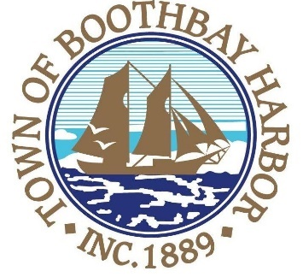
TOWN OF BOOTHBAY HARBOR
SELECTMEN’S MEETING AGENDA
Monday, August 24, 2020
Boothbay Harbor Town Office, 11 Howard Street

7:00 p.m.
Due to limited space in the meeting room to meet COVI9-19 guidelines for safety, we are also providing a Zoom meeting id and number to call for audio purposes:
https://us02web.zoom.us/j/82396780475
MEETING ID: 82396780475 TELEPHONE NUMBER: 1-929-205-6099

CALL TO ORDER:

- Pledge of Allegiance
- Introduction of Town Manager & Board of Selectmen
- Town Manager Announcement(s)
- Town Department Reports
- Selectmen Reports
- Financials
- Minutes Approval – August 10, 2020
- Licenses
  - Liquor License, Extension of Premises, Malt, Spirituous & Vinous, Brady’s Restaurant, 25 Union Street, new
- New Business
  - P.O. International HV 507 4 X 4 (Public Works)
- Old Business
  - Covid-19 discussion
- Public Forum
- Warrants
- Executive Session
- Motion to Adjourn

