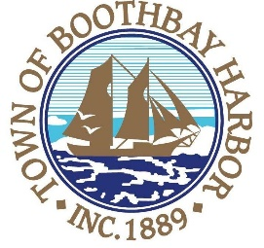
PLANNING BOARD MEETING AGENDA
WEDNESDAY, APRIL 8, 2020 7:00 PM
VIRTUAL MEETING (VIA ZOOM)

- Call to Order

- Roll Call of Members

- Old Business

  - Approval of February 12, 2020, February 19, 2020 and March 11, 2020 Minutes

- New Business

  - Susan Porter, 32 Factory Cove Rd., Tax Map 5, Lot 23, Applicant proposes to raise chickens, requiring Planning Board approval under Chapter 170, Article V, Section 170-27 (e) of the Code of the Town of Boothbay Harbor.

- Other Business
  - PRE-APPLICATION:
    - Project: Eastside Waterfront Park
    - Applicant: Boothbay Harbor Waterfront Preservation
    - Agent: MRLD, LLC
    - Address: 60 Atlantic Avenue, Boothbay Harbor, ME
    - Size: 0.84 Acres
    - Map 16, Lot 24
    - Eastside Waterfront Park is proposed publicly accessible mixed-use park including an expanded working waterfront, a marina, a multi-family home, and a general store.

- Adjourn

Connecting by computer: You may be required to download the Zoom app in order to connect. This is free and easy to use. Make sure to log in a few minutes early to ensure you can connect.
Using your computer, go to https://zoom.us/j/753875318 Meeting ID: 753 875 318

Connecting by phone: Public participants can use their mobile phones using the number (312)626-6799, 753875318#.

PLEASE REMEMBER TO ENABLE AUDIO TO LISTEN TO THE MEETING.

On March 17, 2020, the Maine Legislature enacted emergency litigation (PL2019,c.617) temporarily authorizing remote participation at municipal board and committee meetings by board members and the public. The Planning Board has arranged for the public to safely view or listen to the meetings by remote access. Note that public participants will not be permitted to attend this meeting in person in order to comply with the Governor’s ban. Questions about the board meeting should be directed to Code Enforcement Officer, Geoff Smith at (207) 633-3671 or gsmith@boothbayharbor.org.

