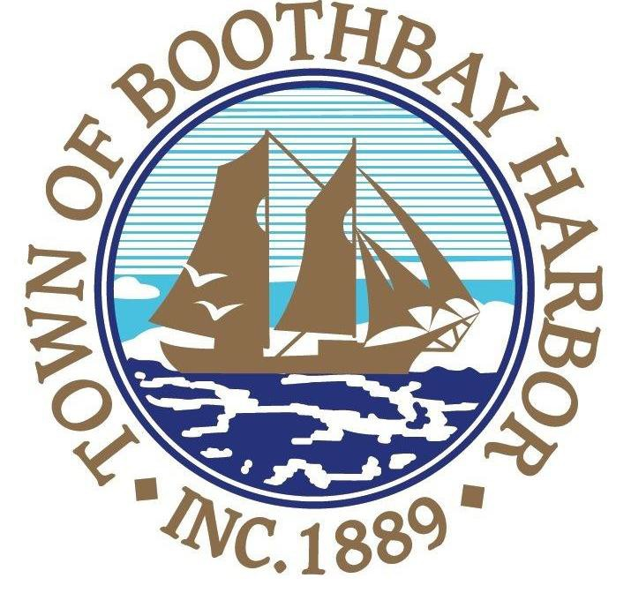
11 Howard Street
Boothbay Harbor, Maine 04538
Tel: 207-633-3671
Fax: 207-633-7712
RE: Public Safety for COVID-19

Dear Boothbay Harbor residents and visitors:
We hope that each one of you are remaining safe and well during this unprecedented COVID-19 pandemic. The Boothbay Harbor Select Board is providing this correspondence so that year-round and seasonal residents have a common understanding of the steps the state of Maine and the town have taken to ensure public safety for everyone in our community.

Effective March 25, 2020, Governor Janet Mills issued an Executive Order mandating that all non-essential businesses and operations in Maine close their physical locations that are public facing, meaning those that allow customer, vendor or other in-person contact. The Governor and Maine Center for Disease Control have also strongly urged everyone to practice physical distancing. It is particularly important for people who are considered at higher risk from COVID-19, such as older Mainers and those with underlying health conditions, to limit physical interactions with other people as much as possible.
Since the beginning of the COVID-19 pandemic, the Boothbay Harbor Town Manager and staff have worked closely with the Select Board to immediately comply with the Governor’s civil emergency orders while striving to provide essential municipal services. Although the town office is closed to visitors, municipal services are available and the staff are prepared to assist you in conducting town business by phone or through the website’s online resources (http://www.boothbayharbor.org ).
We are very proud of how quickly local businesses, nonprofit organizations and residents have responded to these emergency measures. Volunteers are already working with community service groups, businesses and the town to meet the heightened level of basic needs from the closure of so many businesses.

Currently, the town is preparing for the return of seasonal residents and shorter term visitors to Boothbay Harbor from communities where COVID-19 prevalent. Please understand that the arrival of people to seasonal or rental residences increases the exposure risk for community transmission of COVID-19. Accordingly, to help preserve public health and safety, the town requests the following:

RECOMMENDATIONS FOR ALL RESIDENTS as of 4/1/20:
- Delay in short term rentals: If you own a rental property or intend to rent a seasonal property, we request that you defer any rentals until the COVID-19 crisis has abated to limit the additional influx of visitors into our region and help limit community transmission. Note the City of Portland recently suspended all short term rentals in an effort to control the spread of corona virus. We are asking for your voluntary cooperation with this request.

RECOMMENDATIONS FOR SEASONAL RESIDENTS as of 4/1/20:

- If you employ a caretaker or property manager, please contact them in advance of your arrival so they can inspect your premises and make sure your home is ready for immediate occupancy.

- On your arrival in Boothbay Harbor please go directly to your home for a two week period of self-quarantine. This is particularly important for people arriving from high-risk areas – Metropolitan New York City, Long Island, Boston and New Jersey.

  - If possible, please bring the provisions you’ll need for this period of self-quarantine. Our local groceries are doing a superb job of remaining open, but supplies of essential items such as hand sanitizer, toilet paper, disinfecting cleaners and some routine food items are often unavailable or quite limited. In addition, we want to minimize the exposure risk of store employees. Most of our local groceries do not have the capacity for curbside or home delivery service. If you need assistance in obtaining essential items, pleases contact the staff at the Town Office so they can direct you to the appropriate volunteer group for help.

  - Note that local restaurants and nonessential businesses (such as the YMCA, Harbor Theater, Community Center and other sites) in the Harbor are closed under the Governor’s emergency order. Some restaurants are offering limited takeout service.

- If you rent your seasonal property, we request that you defer any rentals until the COVID-19 crisis has abated to limit the additional influx of visitors into our region and help limit community transmission.

The Urgent Care Center at St. Andrews campus has been temporarily closed to consolidate staffing and resources to better respond to the COVID outbreak. LincolnHealth moved their staff from the St. Andrews Urgent Care Center to the Miles campus to support their Emergency Team and the COVID-19 clinic site on the Miles campus. The St. Andrews Family Care Center is open. However, patients with suspected COVID infections should call their primary care doctor and seek care at the Miles campus. We have enclosed a frequently asked question fact sheet from LincolnHealth regarding their response to COVID-19.

As your town officials, we are committed to doing everything we can to preserve the health and safety of people in our community. Certainly we are all grateful to live in a community that has pulled together to help provide essential services, care for our neighbors and ensure that the most vulnerable among us are being cared for during this pandemic.

We ask for your cooperation with these public health measures during this extraordinary time. If you have any questions about the town’s guidance, please contact our Town Manager, Julia Latter at (207) 633-3671 or jlatter@boothbayharbor.org.

Respectfully yours,

Mike Tomko, Select Board Chair
Tricia Warren, Select Board Vice Chair
Denise Griffin, Select Board
Ken F-Fitch, Select Board
Wendy J. Wolf, Select Board

